**Lab No:7**

**Experiment Name:** DHCP Configuration in Cisco Router using Packet Tracer

**Question:**  
Configure a DHCP server on a Cisco router to automatically assign IP addresses to multiple PCs in a network. Explain how DHCP simplifies IP address management compared to manual configuration.

**Apparatus Required:**

* Personal Computer/Laptop (to run simulation)
* Cisco Packet Tracer software
* Router (2 unit – for DHCP server)
* Switch (1 unit – to connect PCs)
* 4–6 PCs (depending on network size)
* Ethernet cables (straight-through)

**Tools Used:**

* Cisco Packet Tracer (for network simulation and DHCP configuration)

**Theory**

**DHCP (Dynamic Host Configuration Protocol):**  
DHCP is a network protocol used to automatically assign IP addresses and other network configuration parameters (such as subnet mask, default gateway, and DNS server) to devices in a network. It eliminates the need for manual IP configuration, reducing human error and simplifying network management. A router can act as a DHCP server, dynamically allocating IP addresses to connected devices from a predefined pool.

When a device (client) connects to the network, it sends a **DHCP Discover** message. The DHCP server responds with a **DHCP Offer**, the client sends a **DHCP Request**, and the server finalizes the process with a **DHCP Acknowledgment (ACK)**. This is known as the **DORA process** (Discover → Offer → Request → Acknowledge).

**ip dhcp pool [name]**

* **Purpose:**
  + This command is used to **create a DHCP pool** on the router.
  + A DHCP pool is a range of IP addresses that the router can assign **dynamically** to clients (PCs, laptops, etc.) on the network.
* **Syntax:**

ip dhcp pool <pool-name>

**Additional Configurations Inside the Pool:**

* **Network/Subnet:** Specifies the IP range and subnet mask.

Eg:network 192.168.3.0 255.255.255.0

* **Default Gateway:** Sets the router IP for clients as their default gateway.

Eg:default-router 192.168.3.1

**Lab diagram:**

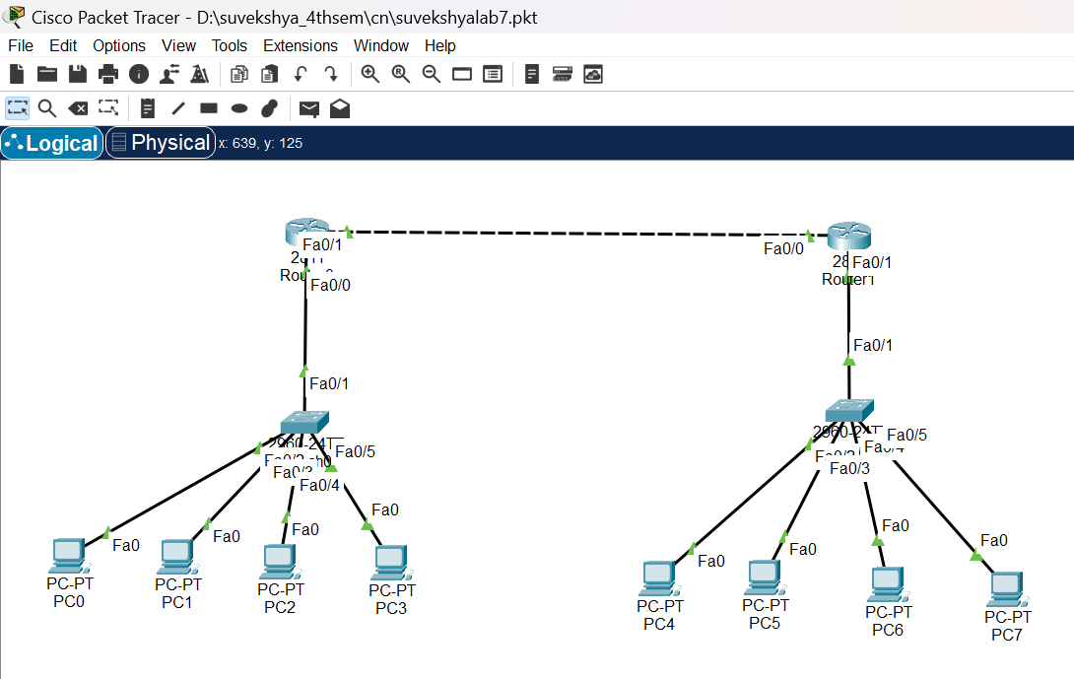

**Procedure**

1. **Set up the Physical Topology:**
   * Open **Cisco Packet Tracer**.
   * Place **two Router** on the workspace (they will act as the DHCP server).
   * For each router,Place **one Switch** to connect all the end devices.
   * Add 4 pcs as end devices to eacg switch.
   * Connect the devices using **straight-through Ethernet cables** as follows:
     + Router → Switch (FastEthernet interface)
     + Each PC → Switch (FastEthernet interface)
   * Ensure all cables are correctly connected

**2.Router Configuration:**

**On router 1(suv-rtr):z**

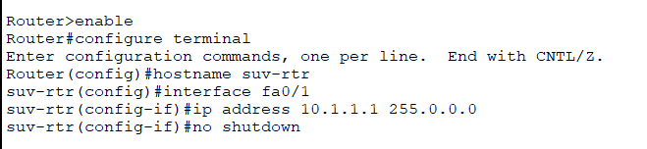

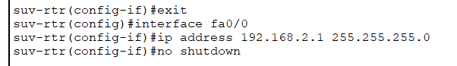

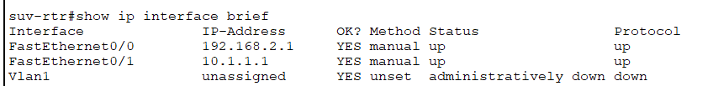

In router2(suv-rtr1):

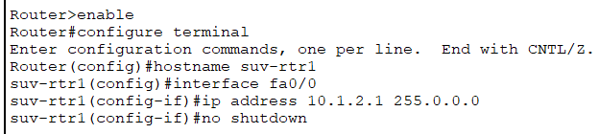

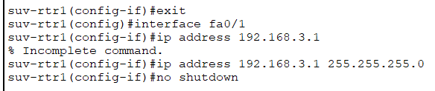

**3. Configuring DHCP on the Router**

**In router1(suv-rtr):**

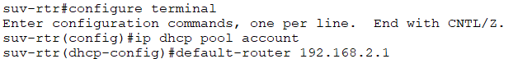



In router2(suv-rtr1):

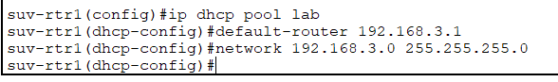

4. **Configure PCs for Dynamic IP Addressing**

In network1(192.168.2.0):

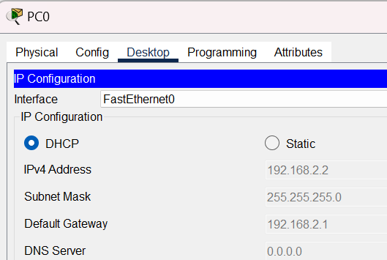

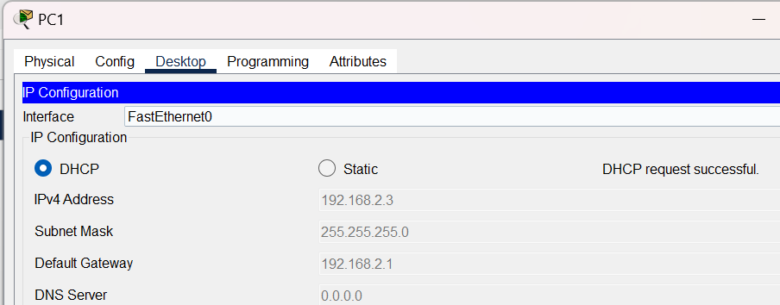

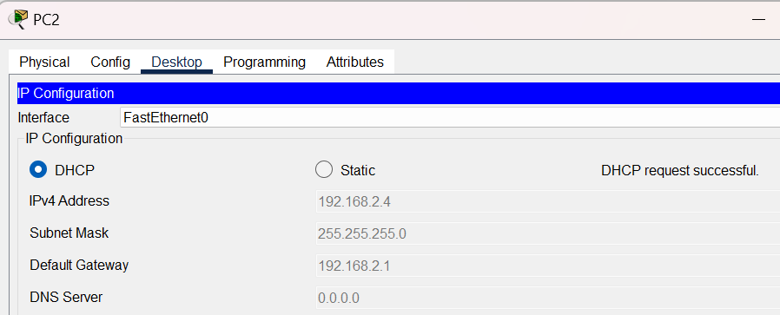

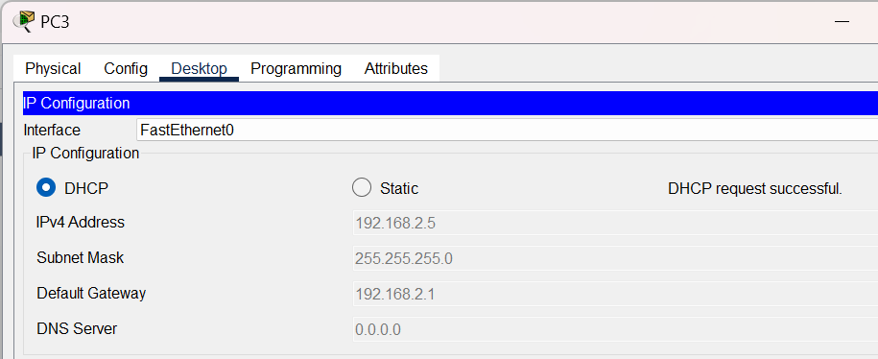

In network2(192.168.3.0):

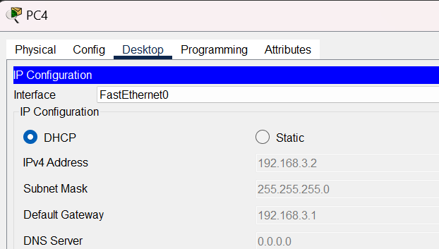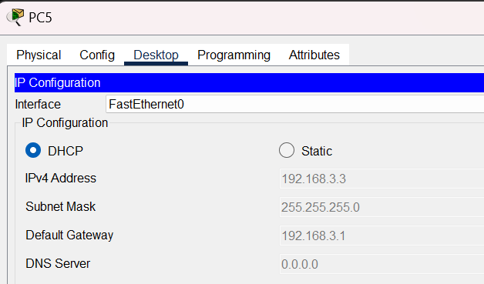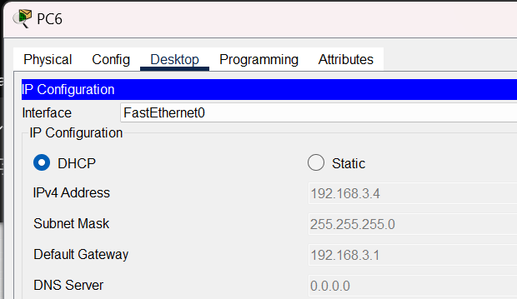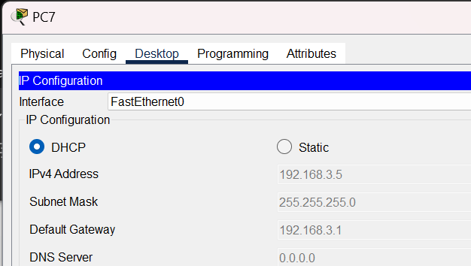

**Testing**:

1. Test Connectivity (Ping Test) from pcs to their respective routers:

for router1(suv-rtr) in network1(192.168.2.0):

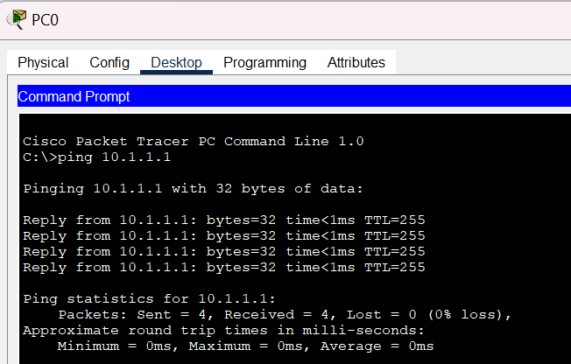

for router2(suv-rtr1) in network2(192.168.3.0):

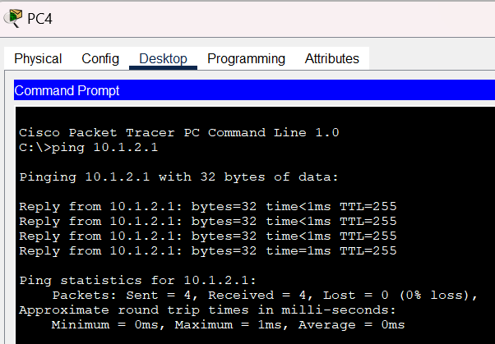

2. Check Router DHCP Binding:

In router1(suv-rtr):

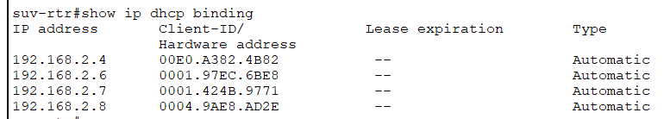

In router2(suv-rtr1):

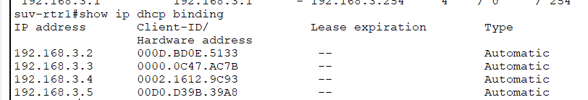

**Conclusion**

In this experiment, we successfully configured **DHCP (Dynamic Host Configuration Protocol)** on a Cisco router using Packet Tracer. By setting the PCs to obtain IP addresses dynamically, the DHCP server automatically assigned IP addresses, subnet masks, and default gateways from the predefined pool. This eliminated the need for manual IP configuration, reduced the chances of IP conflicts, and made network management easier and more efficient.